|  |  |
| --- | --- |
| Course name:  Diploma in Software and Design | |
| Assignment title | **DSD-04 Agile Group Project** |
| Assessment weighting | *Need to pass the assessment to complete the course* |
| Passing Criteria: | Need to score 50% or more to pass the assessment.  **Total Marks: 100** |
| Due date: | **Your Tutor will advise you**  (late submissions incur 10% penalty, after 7 days late, the assessment will not be marked) |
| Assessment conditions: | This is a resource-based assessment. This means that you may have access to any relevant resources to assist you.  This could include your learning materials, information on the Internet, and so on. However, all work must be your own with no assistance from any other person. |
| Submission requirements: | Upload your project to Github or Cloud Campus |
| Module Names and Learning Outcomes | **Project Management**   * 1. Identify requirements and implement mobile solutions * 2. Conduct project planning activities that accurately forecast project costs, timelines, and quality. Implement processes for successful resource, communication, and risk and change management. * 3. Use an appropriate methodology for project management * 4. Demonstrate effective project execution and control techniques that result in successful projects * 5. Satisfy client expectations and meet client needs in executing a software development project |

This is an **ONLINE** only assessment. No paperwork is needed.

**Disclaimer of Plagiarism and Collusion**

I declare that:

* I have read and understood the ATC Vision Collage “Assessment Policy” and “Academic Cheating” sections as described in the Student Handbook.
* I am aware of the penalties for cheating as described in the Student Handbook.
* This assessment submission is entirely my own work, I have quoted, referenced and acknowledged any work copied directly from another source.
* I understand this assessment submission may be used for internal and/or external moderation.

I understand that if I have circumstances that affect my progress to complete assessment tasks, I will discuss it with my tutor prior to submission date

# Agile Group Project

## Objective

The students are required to undertake a group project as part of their Assessment for the Diploma in Software Engineering and Design qualification. The students are required to build an Android app using Agile methodologies. The App will also use a Source Control system such as Git.

## Purpose

The purpose of the assessment is to create an Android App using Agile and Scrum methodologies.

The intention is that all group projects should be successful, and all students are expected to contribute to their own project in accordance with the timetable.

Group projects are expected to take students 180 hours of work per student, spread over 6 to 7 weeks, and to enable students to display their understanding across a broad range of subjects.

Groups will be expected to exhibit professional skills in design, quality and management. Specifically, they will have to show that the work has been carefully planned, that components and systems have been properly tested, and that members of the group have cooperated effectively.

The exercise also gives students experience of working against deadlines, with a team of colleagues. This gives some idea of the problems encountered in normal professional practice.

The review meetings provide an opportunity to monitor group progress and for general discussion. Your tutor will attend all the review meetings.

### Requirements

Create a mobile app using Agile and Scrum methodologies. The final app may not be totally finished owing to time constraints. But still be operatable.

## Final deliverables

Copy and paste the questions below into a new document, answer them, and put it in your assessment folder with a copy of the app.

**Answer the following questions.**

What was the App that your group created?

**Answer:**

An app using Xamarin is created in this group task, named as “Expense App”.

### Agile / Scrum

1. What did you learn about how the Agile and Scrum methodologies operate?

**Answer:**

Agile is a continuous iteration of development and testing in the software development process whereas Scrum is an Agile process to focus on delivering the business value in the shortest time. Agile methodology delivers the software on a regular basis for feedback while Scrum delivers the software after each sprint.

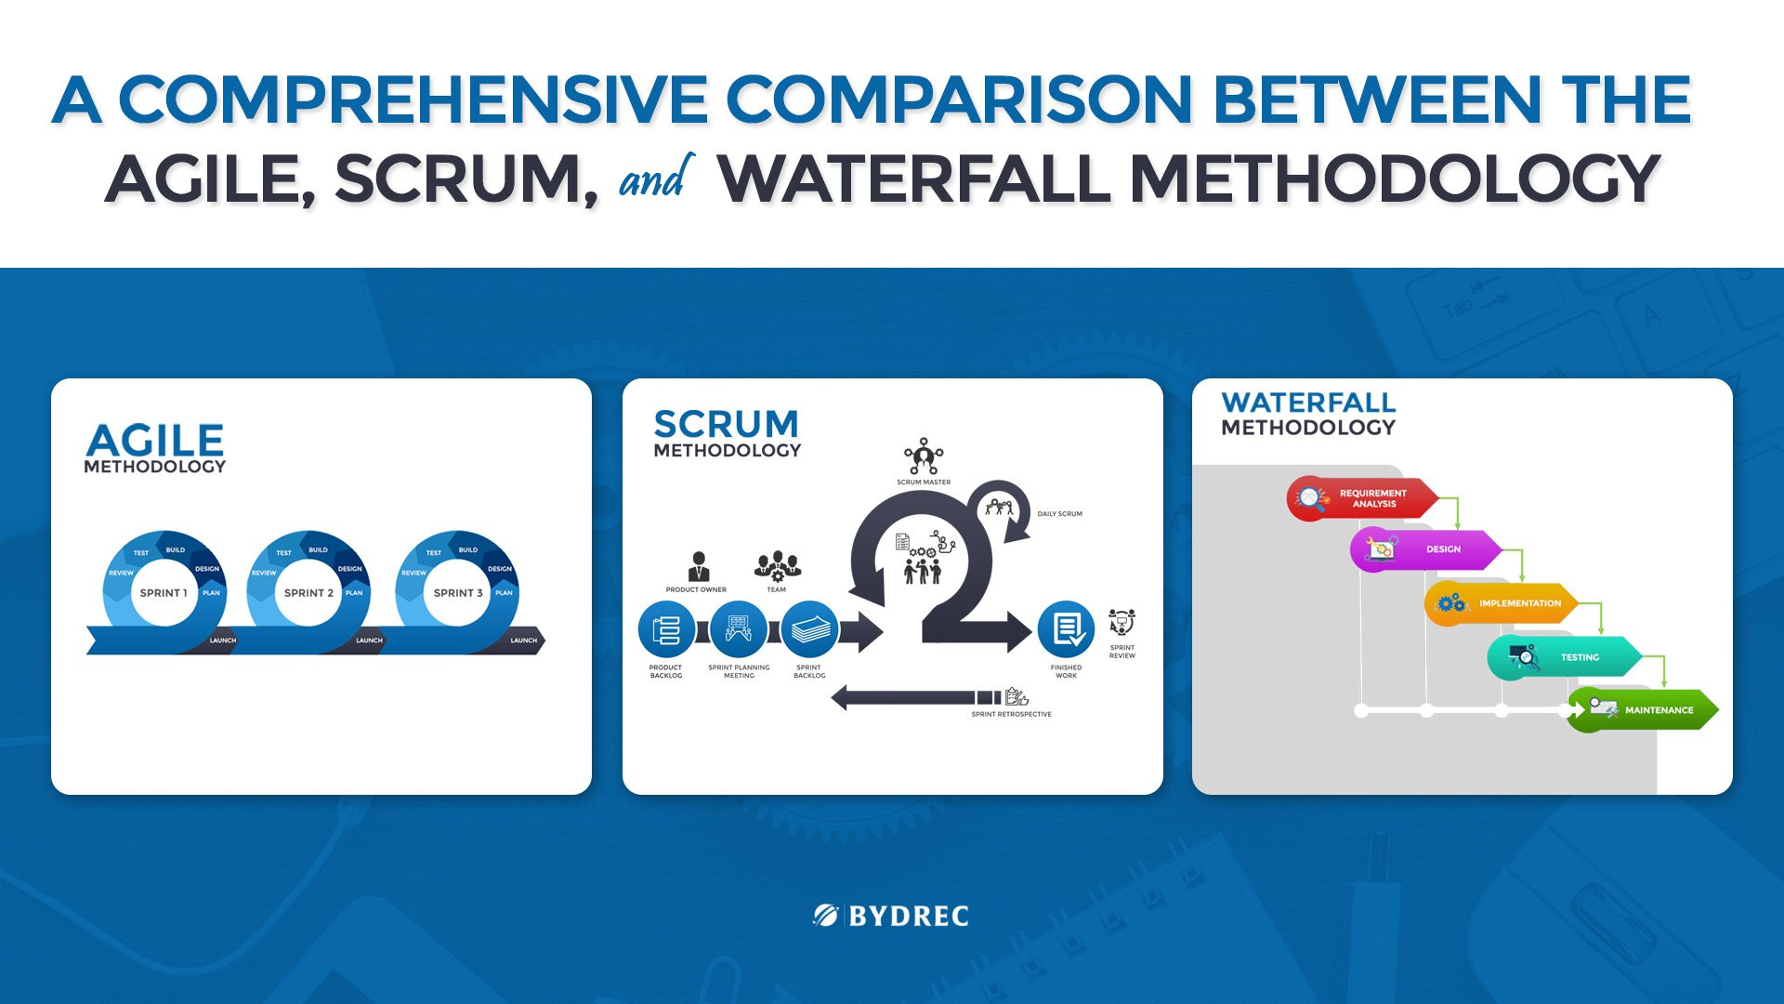

1. In practice how effective did you find this methodology?

**Answer:**

Agile practices to grow faster, then here is the answer! Agile Practice in the organization improves its project management capabilities and improve performance.

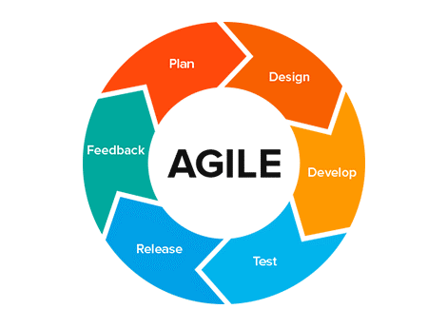

1. What did you find was the strength of it?

**Answer:**

The strengths I found for the agile methodology are as follows:

* High **flexibility** of the project. Short cycles and constant iterations allow you to adapt your project frequently and tailor it to the customer’s needs at any moment. You don’t have to waste your time and resources on delivering a full project which will be rejected by the customer. This makes the development process extremely flexible.
* **High customer satisfaction** over the development process. Since Agile projects are closely coordinated with the customer, he/she has a strong impact on the development project. Software pieces are delivered constantly, in short cycles and customer’s feedback is always taken into consideration.
* **Constant interaction** among the stakeholders. With your teams constantly interacting with each other and with the customer, you avoid producing tons of technical documentation, processes, and tools. Each member feels like an important part of the team participating in the decision-making process. This stimulates creativity and initiative and leads to better results.
* **Continuous quality assurance**, attention to details. Quality of the product should be ensured by the testing team from the early stages of [Agile development](https://hygger.io/blog/brief-introduction-agile-development/). Since the development is conducted in short cycles, testing is run non-stop, allowing you to produce a good final product.

1. What were its weaknesses?

**Answer:**

The weaknesses I identified during this group project are stated as follows:

* Problems with **workflow coordination.** Agile projects involve several small teams working on their own software pieces. They should always coordinate their work with each other, testers and management. Add to that constant interaction with the customer, and you will get a ton of communication management to consider before starting the project. Even though a lot of interaction is considered an advantage of Agile methodology, it may become a weak point due to many factors.
* **Difficult planning** at early stages. Planning in Agile development is essential before the process is started. It is important to assess your resources, build up teams, and communicate an overall vision of the project to them before it is kicked off.
* **Professional teams are vital**. Agile projects require [teams](https://hygger.io/blog/agile-team-building/) to make serious decisions constantly. It means that only experienced software developers, testers, and managers should be working on the project. This software development methodology provides a very few places for rookies.
* **Lack of long-term planning**. A lack of final vision of the project may be disorganizing in some cases. Your project may end up off track if the customer changes his mind too often during the process. And remember, by the end of the project you will have to assemble all those software pieces, which had been changed and adapted a few times over the development cycle and make them work. Also, there will be weak documentation, since the interactions with the customer were mostly verbal.

1. What were the best features of the process?

**Answer:**

The features of agile methodology that are best according to me are stated as follows:

* Flexibility due to agility.
* Transparency of the project due to agility.
* Productivity of the agile methodology.

1. How did they appeal to you?

**Answer:**

These features appeal me as they make my client more comfortable with the work as these features help to involve the client in all the development process of the app. And helps in achieving the client’s satisfaction.

1. What was the worst feature of the process?

**Answer:**

The worst feature I've found in this process is the constantly growing customer requirements. Since there are always new requirements and changes, the development time is endless.

1. How would you change them?

**Answer:**

I think we can make a brain storming session to overcome creepy requirements.

### Group work

1. What did you enjoy about this style of programming?

**Answer:**

I have enjoyed the cooperation of the customer with the project because of the visibility of all functionalities and progress in the project by both the customer and the developer.

1. What are the downsides for you of group work?

**Answer:**

This methodology disturbs the work flow while working in group this seems to be more annoying.

1. How did this session change your opinion of working in industry?

**Answer:**

This session changed my mind, as I became aware of the fact that it is not as easy for the customer to work in the industry to deal with technical and complex issues in a practical environment.

### Source Control

1. What form of Source Control did you use?

**Answer:**

We have used “GitHub”

1. What were its strengths?

**Answer:**

The strengths for using GitHub are stated as follows:

* It makes it easy to contribute to your open-source projects. To be honest, nearly every open-source project uses GitHub to manage their project.
* Documentation.
* Showcase your work.
* Markdown.
* GitHub is a repository.
* Track changes in your code across versions.
* Integration options.

1. What were its weaknesses?

**Answer:**

The weaknesses for using GitHub are:

* Security of the GitHub.
* Pricing of the features.

1. How effective as a source control did you find it?

**Answer:**

I found this methodology very effective as this helps in managing the app versions efficiently and can easily be integrated with any cloud.

1. If you had to use it again what would you change?

### Other

1. Do you feel that this has been a worthwhile experiment?

**Answer:**

Yes.

1. Why? Why not?

**Answer:**

I found it worth experimenting, since it helps me to gain practical knowledge of the agile development of apps.

1. **If you had to give yourself a percent grade for your contribution to the project, and the process, what would it be?** Bearing in mind that you might have produced little, yet done the hard yards. Or you made heaps, but it was really easy.

**Answer:**

I'd like to award me an A because the job I display is small but the commitment behind this little success is immense.